***Blood Faith IX***

My dearest Porfirio,

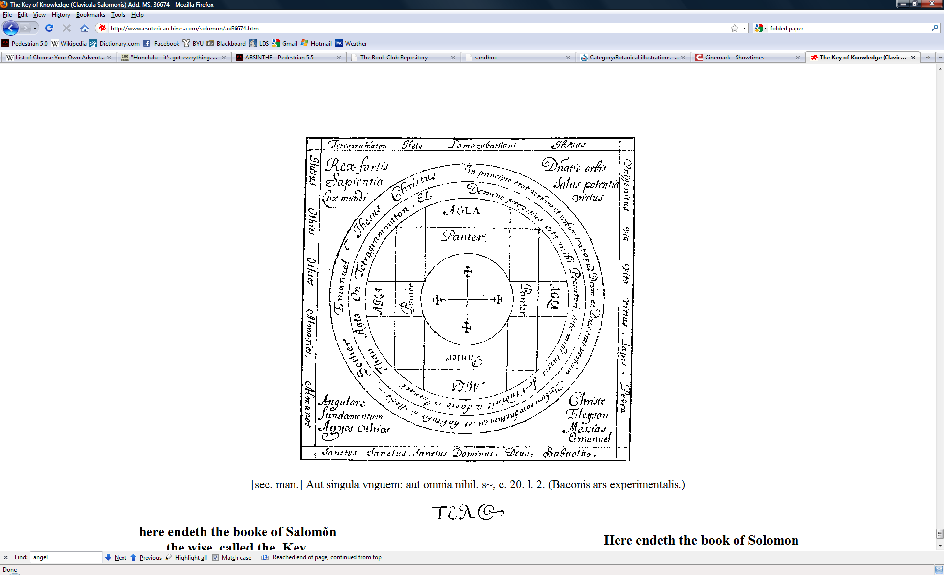

As you have probably by now ascertained, Hæmming is holding me captive here in al-Qāhira. I use the term ‘captive’ loosely, since he does allow me a pretty long leash. He won’t let me come to you in Lutetia Parisiorum, but I *am* allowed to wander as far as al-Iskandariyya, where I’ve spent countless hours in the *bibliothekai*. But Hæmming often accompanies me, which limits my topics of interest to a dull few. I would’ve fled to you by now, but Hæmming constructed a *defixio* using some of my hair and so I am bound. I do not know where he has hidden it, nor how he obtained my hair so that he could construct it. But until I find it, I am compelled to remain.

But on to the matter at hand: four months ago, to my surprise, I saw Hæmming remove a scroll from the library. He not only hid the fact from the caretakers, but he also tried to hide it from me. Intrigued, I played stupid so that he wouldn’t suspect that I’d seen his little pilfer. When we returned, I waited until he’d gone to lunch with Blüðgard and then I sneaked into his room. It didn’t take me long to discover the scroll he’d purloined—since he disbelieved that I knew he’d taken it, he hadn’t gone to great lengths to conceal it. Now if only finding my *defixio* were that easy…

Anyhow, I pulled it out and opened it up. It was an old copy of the grimoire *Clavis Salomonis*. I couldn’t imagine why *kabbalah* and Basilidean Gnosticism would concern Hæmming, so I began reading it. Unfortunately, while the magic circles were still in Latin, Greek, and a little Hebrew and Aramaic, the majority of the text had been translated into a bizarre admixture of Demotic and Coptic (as well as a few inscriptions in *lišānum akkadītum* and Q’eqchi’—imagine that!). Needless to say, that made for difficult reading. That, coupled with the fact that Hæmming got suspicious and hid the scroll in the Catacombs of Kom el Shoqafa, meant that it took me several months to finish the text. Luckily, Hæmming doesn’t seem to have finished it, yet.

Most of it was silly *hoc est corpus*. However, two things caught my attention. Both were magic circles. Lest they fall into the wrong hands, I’ve imprinted them onto these pages as a watermark which only our Shed eyes can perceive. The first elaborates on the process of the Reclamation (and perhaps this is what Hæmming sought).

The second included a passage. It has nothing to do with the Reclamation, but I feel it may be even more monumental. Do you remember a few years ago hearing about an antilegomena called the *en archē vrykolakas*? It caused quite a stir which the Council quickly quelled by destroying all the copies they could get their hands on and subjecting anyone caught in possession of a copy to the *druj-demana*. From the little bit that I heard (and as the title suggests), the treatise dealt with the origins of our Philosophy and the purpose of our existence. But it was contrary to what the Council had canonized.

Here is the best translation I could manage:

In the Dark Times before the Foundation of the Earth, the Sons of Eternity, both great and small, lived between the *lamassu* in the Empyrean Realm. They plumbed the depths of Formless Desolation and stared at the naked Emptiness. Confusion seeped through the darkness, but found nothing to grip. Then Eternity decided to fill the Emptiness and give form to the Desolation. The Sons of Eternity shouted with joy, but not all. Some, called the Morning Stars, saw Defeat in this new Plan. Their leader, the Son of Dawn, was eventually vanquished and he and his followers were thrust into the new Material Realm, which dulled their Powers and diluted their Senses.

This Curse, this Punishment, was too much for them to bear. They Rebelled. And in their Rebellion they drew upon themselves the wrath of Eternity. From the Almighty Throne, the Eternal began to regret his Clemency towards the Morning Stars. He commanded their Destruction. But in the Material Realm he could not Comminute them.

Thus began the Great Plan of Restoration. Means were devised whereby Mankind, the Pinnacle of the Material Realm, could Shed his Mortality. Thus transfigured, the Eternal endowed them with the Ability to hunt the Morning Stars and return them to the Gap between the *lamassu*. This path was rigorous and only the most dedicated could tolerate the transit. Once a sufficient number had concluded this Rite of Passage, the Hunt began. The Morning Stars fled the Destruction of the New Immortals only to find Comminution awaiting them among the *lamassu*.

Soon only the most powerful Morning Stars remained. Long they eluded the Hunters, but eventually (after a false trail which led them to the Bodélé Depression) the Hunters tracked them to the Mountains of the Moon, deep within Blackest Africa. There the Hunters destroyed the last of the Morning Stars. The Destruction was so great that to this day it is impossible for the New Immortals to reach the Mountains of the Moon. But one of the Morning Stars was missing: the Leader, the Original Rebel, the Son of Dawn. He had escaped. He lay hidden for many Centuries, but eventually he was found on the southern end of the *Chersónēsos tou Haímou*. The Greatest of the Hunters came together to face him. There the Son of Dawn perpetrated an Act so Heinous, so Wicked, that the Earth Reeled and the Society of the Hunters was Corrupted.

That’s all it says. The rest of the page was torn. On the next page in the grimoire I found reference to an event called the Demarche, which I wonder if it refers to the ‘Act so Heinous, so Wicked’. It was scrawled on the bottom margin in a hasty hand, as though the writer were doing something forbidden and didn’t wish to be caught:

He who wishes to learn of the Demarche, that most Unholy of Events, must seek *The Book of Abramelin* in the tombs of Caesar Augustus.

I cannot determine whether those we call the Opposition constitute the Sons of Eternity or a faction of the Hunters that weren’t corrupted by the Son of Dawn. The Council and our elders are so reticent about revealing anything about the Opposition. And when they do, they are purposefully vague and misleading, I think. Either way, I fear that our Society is in error. What if we’ve chosen the wrong side?!!

I need you, my belovéd. I know not what to do; I grow restless. Since I cannot come to you in Lutetia Parisiorum, you must come to me. I eagerly await the day when we can again suck the mortal sap together. But be wary of Hæmming—I suspect he has some purpose in requesting you to be here. It certainly bodes ill that he’s using me as bait to get you here. And I am almost certain that it was he who stole my notes. Remember he is ancient and wily. Be careful!

Yours and only yours,

Sibyl